Supporting Information
Rec. Nat. Prod. X:X (202X) XX-XX
A Novel Limonoids From The Seeds Of Chisocheton macrophyllus

Nurlelasari¹, Muhammad Badrul Huda¹, Wahyu Safriansyah¹, Unang Supratman^{1,2}, Yudha P. Budiman¹, Desi Harneti P. H.¹, Rani Maharani¹, Tri Mayanti¹, Kindi Farabi¹ and Sofa Fajriah³,

¹Department of Chemistry, Faculty of Mathematics and Natural Sciences, Universitas Padjadjaran,
Jl. Raya Bandung-Sumedang Km 21, Jatinangor 45363, West Java, Indonesia
²Central Laboratory of Universitas Padjadjaran, Jl. Raya Bandung-Sumedang Km 21, Jatinangor 45363, West Java, Indonesia.
³Research Center for Pharmaceutical Ingredients and Traditional Medicine, National Research and Innovation Agency (BRIN), Complex Cibinong Science Center – BRIN., Cibinong 16911, Bogor,
Jawa Barat, Indonesia

Table of Contents | Page
Figure S1: HRTOF-MS spectrum of compound 1 | 3
Figure S2: UV spectrum of compound 1 | 3
Figure S3: FTIR spectrum of compound 1 | 4
Figure S4: ¹H-NMR (500 MHz, CDCl₃) spectrum of compound 1 | 5
Figure S5: ¹H-NMR (500 MHz, CDCl₃) spectrum of compound 1 (From δ 3 ppm to 0 ppm) | 5
Figure S6: ¹³C-NMR & DEPT135 (125 MHz, CDCl₃) spectrum of compound 1 | 6
Figure S7: HSQC spectrum of 1 | 6
Figure S8: HSQC spectrum of compound 1 (From δC 160 ppm to δC 70 ppm) | 7
Figure S9: HSQC spectrum of compound 1 (From δC 120 ppm to δC 70 ppm) | 7
Figure S10: HSQC spectrum of compound 1 (From δC 50 ppm to δC 10 ppm) | 8
Figure S11: HSQC spectrum of compound 1 (From δC 30 ppm to δC 10 ppm) | 8
Figure S12: ¹H-¹H COSY spectrum of compound 1 | 9
Figure S13: HMBC spectrum of compound 1 | 9
Figure S14: HMBC spectra of compound 1 (From δC 200 ppm to δC 50 ppm) | 10
Figure S15: HMBC spectrum of compound 1 (From δC 170 ppm to δC 40 ppm) | 10
Figure S16: HMBC spectrum of compound 1 (From δC 170 ppm to δC 40 ppm) | 11
Figure S17: HMBC spectrum of compound 1 (From δC 170 ppm to δC 20 ppm) | 11
Figure S18: NOESY spectrum of compound 1  Figure S19: SciFinder search report  Table S1 : Comparison data between the new compound with dysobinin | 12  13  14

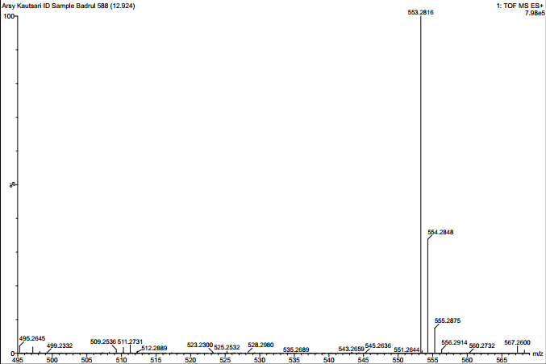
Figure S1: HRTOF-MS spectrum of compound 1
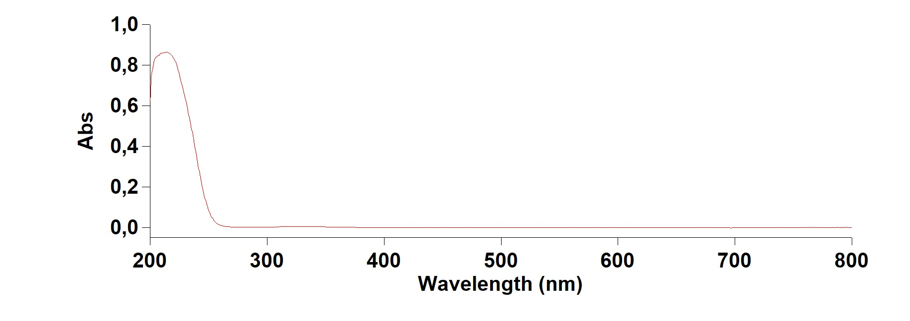
Figure S2: UV spectrum of compound 1

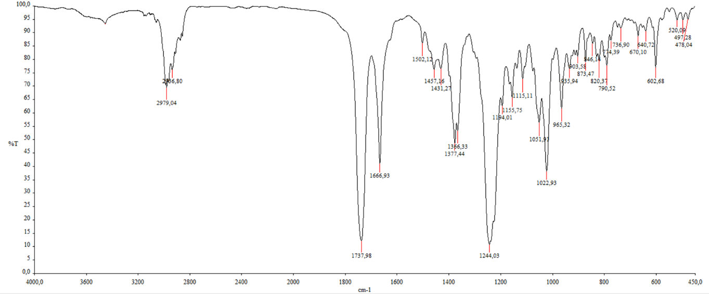
Figure S3: FTIR spectrum of compound 1

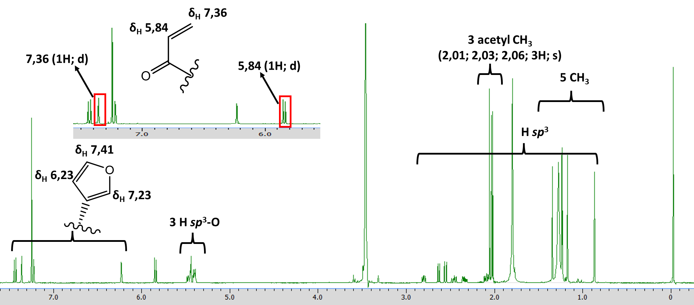
Figure S4: ¹H-NMR (500 MHz, CDCl₃) spectrum of compound 1

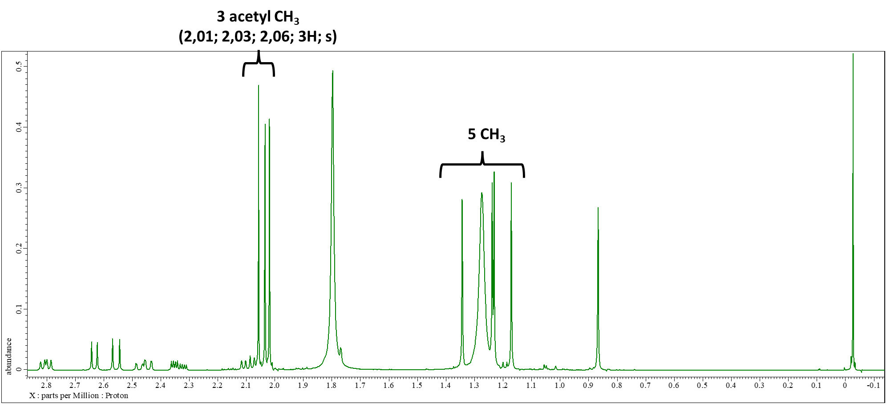
Figure S5: ¹H-NMR (500 MHz, CDCl₃) spectrum of compound 1 (From δ 3 ppm to δ 0 ppm)
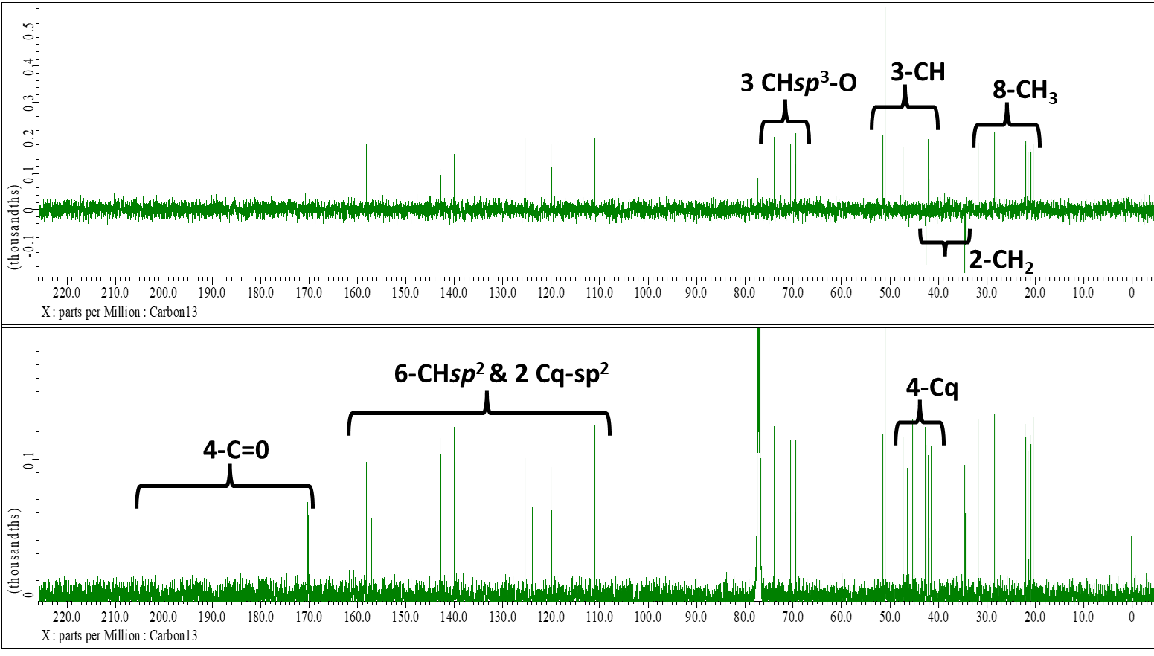
Figure S6: ¹³C-NMR & DEPT135 (125 MHz, CDCl₃) spectrum of compound 1
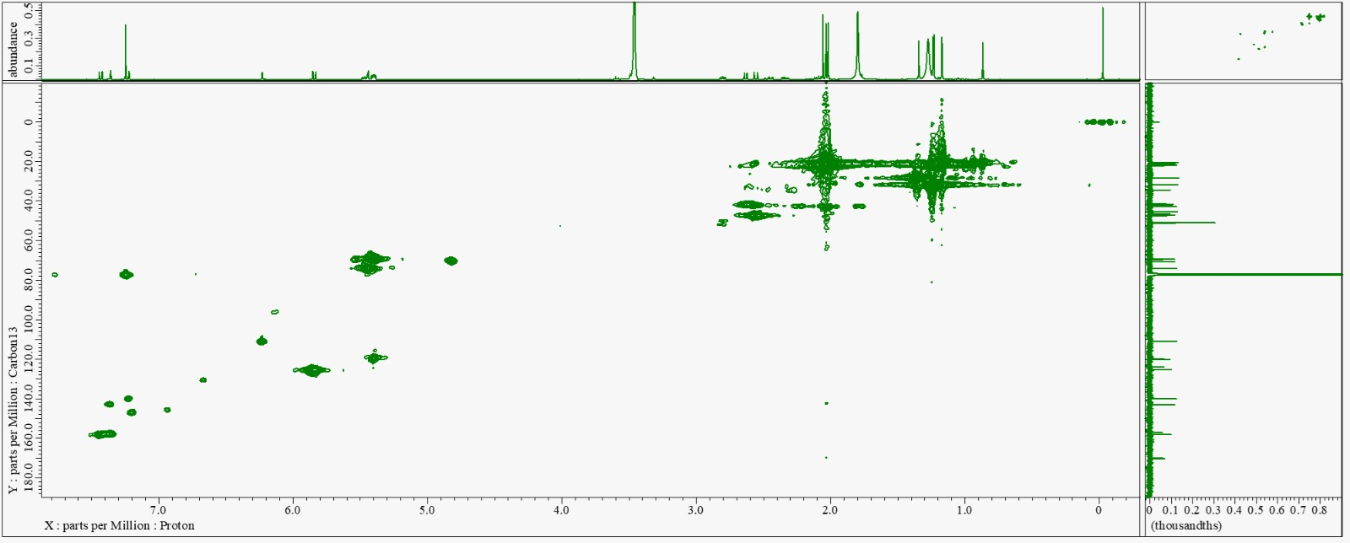
Figure S7: HSQC spectrum of compound 1

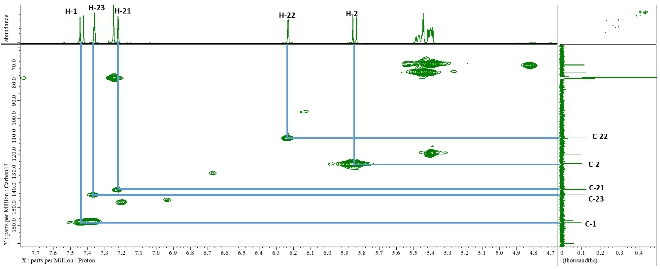
Figure S8: HSQC spectrum of compound 1 (From δ_{C} 160 ppm to δ_{C} 70 ppm)
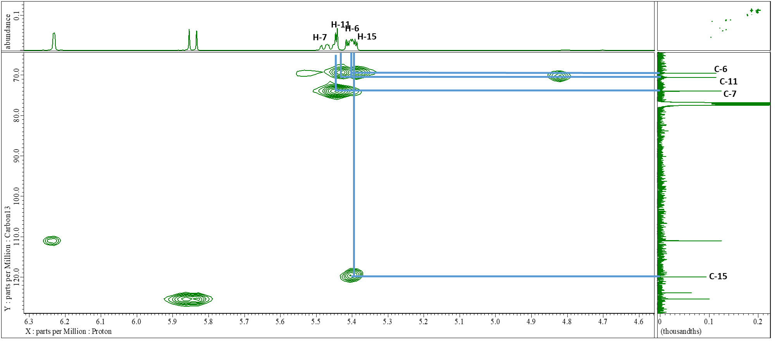
Figure S9: HSQC spectrum of compound 1 (From δ_{C} 120 ppm to δ_{C} 70 ppm)
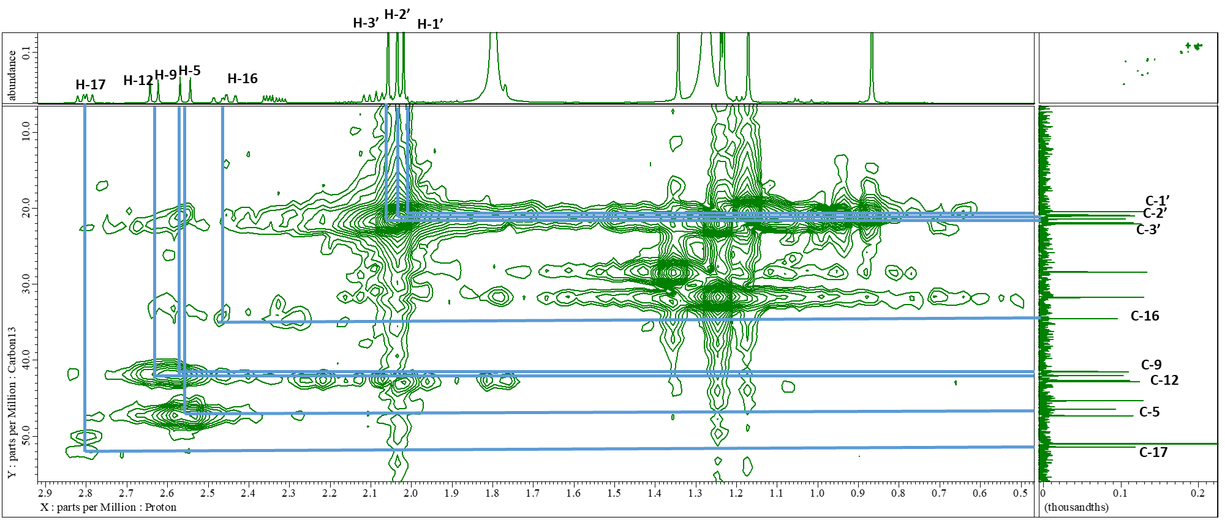
Figure S10: HSQC spectrum of compound 1 (From δ_{C} 50 ppm to δ_{C} 10 ppm)
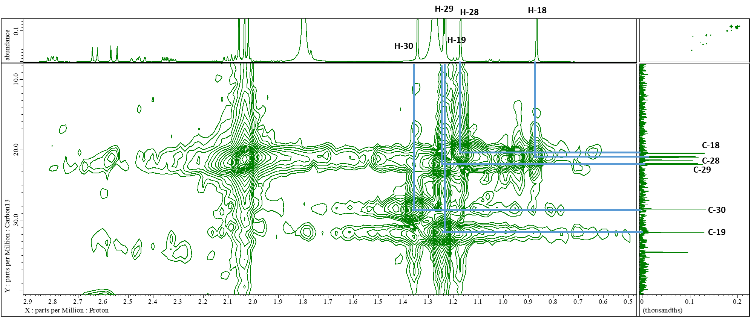
Figure S11: HSQC spectrum of compound 1 (From δ_{C} 30 ppm to δ_{C} 10 ppm)
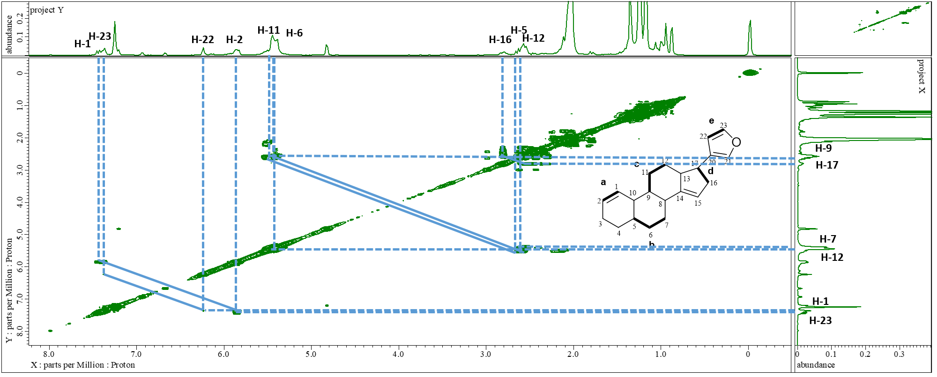
Figure S12: ¹H-¹H COSY spectrum of compound 1

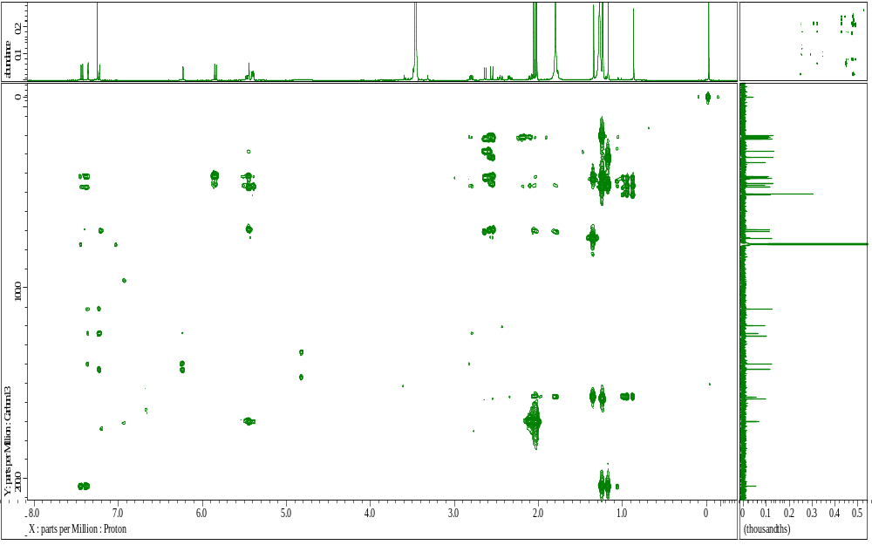
Figure S13: HMBC spectrum of compound 1
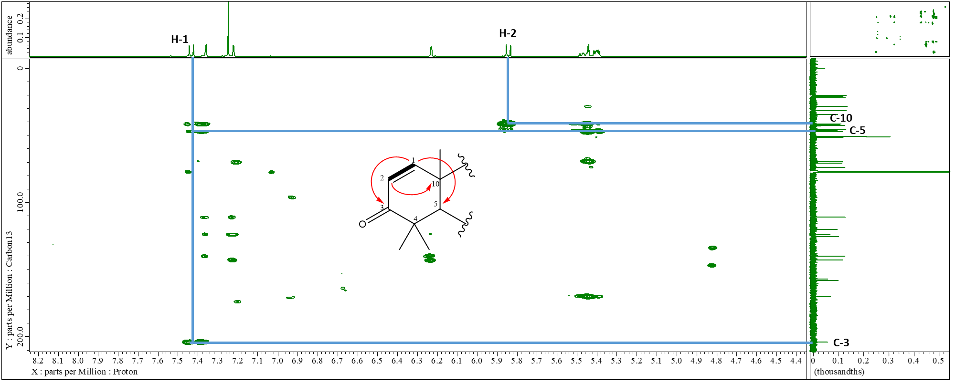
Figure S14: HMBC spectra of compound 1 (From δ_{C} 200 ppm to δ_{C} 50 ppm)

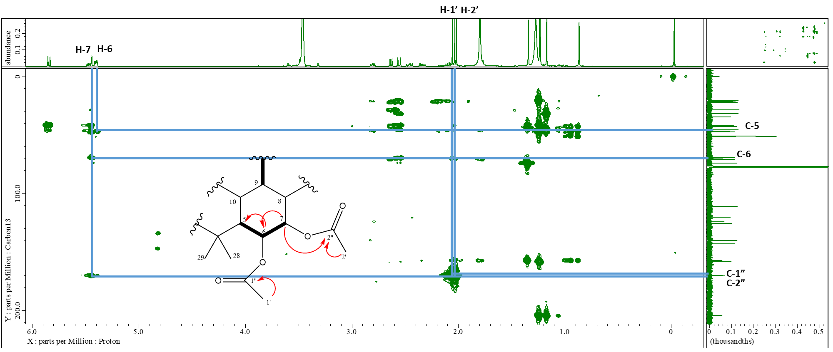
Figure S15: HMBC spectrum of compound 1 (From δ_{C} 170 ppm to δ_{C} 40 ppm)
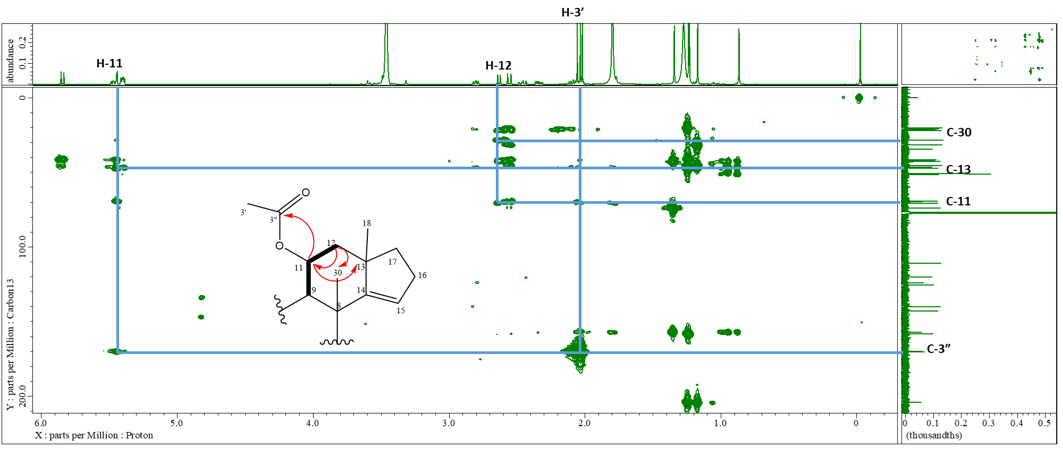
Figure S16: HMBC spectrum of compound 1 (From δ_{C} 170 ppm to δ_{C} 40 ppm)
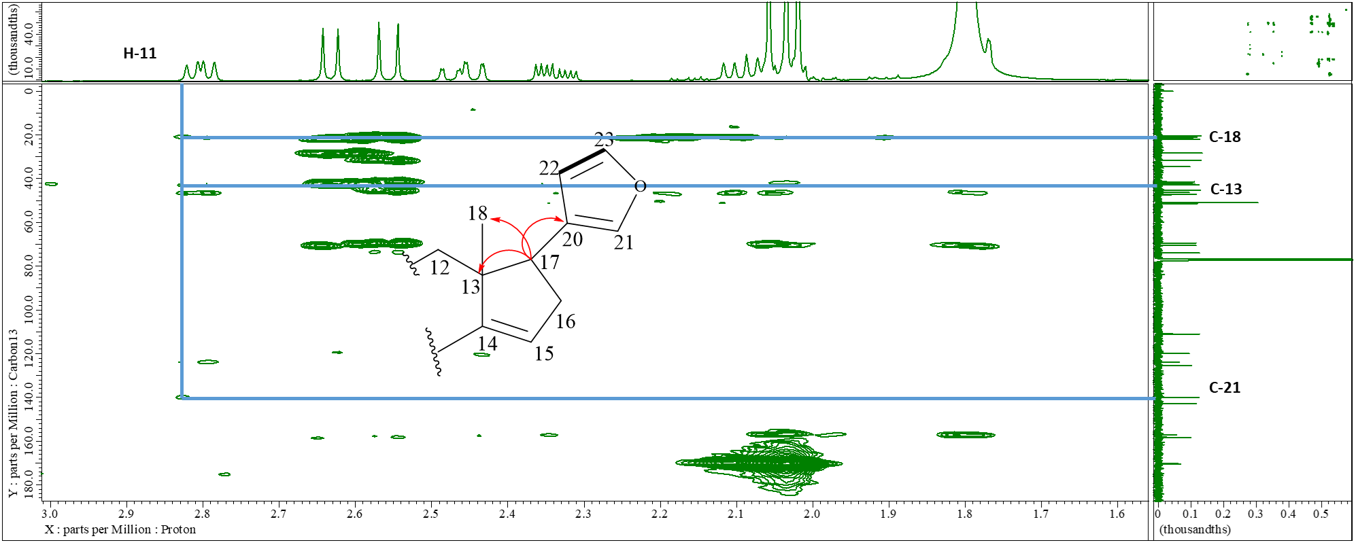
Figure S17: HMBC spectrum of compound 1 (From δ_{C} 170 ppm to δ_{C} 20 ppm)
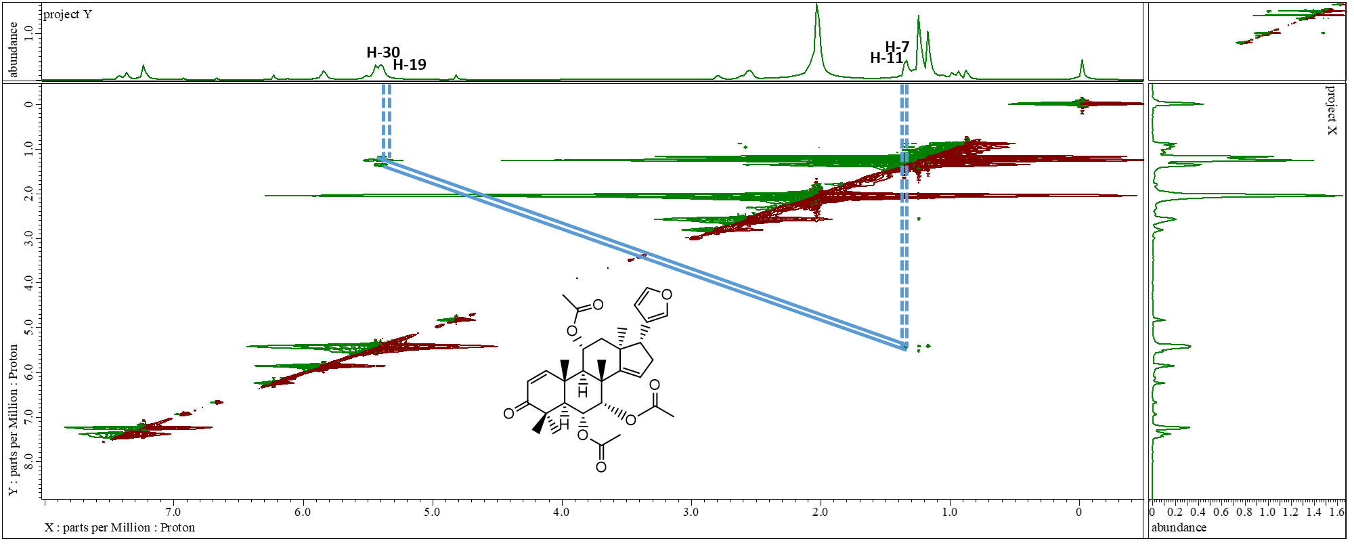
Figure S18: NOESY spectrum of compound

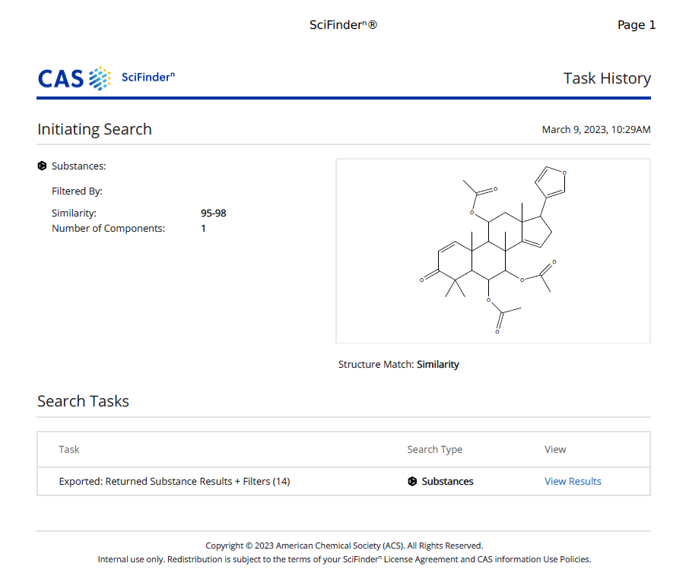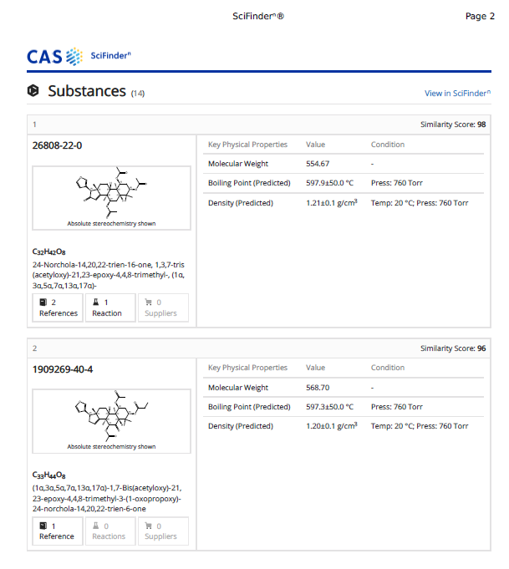
Figure S19: SciFinder search report
Table S1: Comparison data between the new compound with dysobinin
C | Dysobinin |  | 11 α-acetoxydysobinin
C | ¹H-NMR (500 MHz) | ¹³C-NMR (125 MHz) | ¹H-NMR (500 MHz) | ¹³C-NMR (125 MHz)
C | δH ppm (ΣH; mult; J=Hz) | δC ppm | δ_{H} ppm (ΣH; mult; J=Hz) | δC ppm
1 | 7.3 (1H; d; 10.3) | 158.2 | 7.36 (1H; d; 10.3) | 158.3
2 | 5.84 (1H; d; 10.3) | 126.6 | 5.86 (1H; d; 10.3) | 125.4
3 | - | 204.1 | - | 204.1
4 | - | 45.6 | - | 47.3
5 | 2.5 (1H; m) | 48.9 | 2.56 (1H; d; 12.4) | 45.3
6 | 5.40 (1H; m) | 70.0 | 5.46 (1H; m) | 69.5
7 | 5.40 (1H; d) | 75.1 | 5.43 (1H; d; 2.5) | 73.9
8 | - | 43.9 | - | 42.8
9 | 1.28 (1H; m) | 38.3 | 2.57 (1H; m) | 42.0
10 | - | 41.6 | - | 41.5
11 | 1.80 (1H; m) | 17.0 | 5.45 (1H; d; 7.7) | 70.6
12 | 2.3 (1H; m); 2.5 (1H; m) | 35.3 | 2.63 (2H; d; 12.4) | 42.6
13 | - | 47.9 | - | 46.4
14 | - | 159.7 | - | 157.1
15 | 5.40 (1H; m) | 120.2 | 5.40 (1H; d; 7.7) | 120.0
16 | 1.73 (1H; m); 1.93 (1H; m) | 33.6 | 2.47 (2H; m) | 34.5
17 | 2.84 (1H; dd; 7.4; 11.3) | 52.7 | 2.81 (1H; dd; 11.0; 7.3) | 51.4
18 | 1.35 (3H; s) | 27.1 | 0.87 (3H; s) | 20.9
19 | 1.22 (3H; s) | 32.1 | 1.23 (3H; s) | 31.7
20 | - | 125.5 | - | 123.9
21 | 7.40 (1H; s) | 140.9 | 7.23 (1H; s) | 139.9
22 | 6.40 (1H; d) | 112.0 | 6.23 (1H; dd; 1.8; 0.9) | 111.0
23 | 7.50 (1H; d) | 143.7 | 7.43 (1H; d; 10.3) | 142.9
28 | 1.15 (3H; s) | 20.7 | 1.17 (3H; s) | 20.5
29 | 1.22 (3H; s) | 20.9 | 1.24 (3H; s) | 22.0
30 | 1.22 (3H; s) | 21.2 | 1.34 (3H; s) | 28.4
1’ | 2.00 (3H; s) | 21.3 | 2.03 (3H; s) | 21.4
2’ | - | 170.6 | - | 170.1
1’’ | 2.00 (3H; s) | 22.4 | 2.01 (3H; s) | 21.1
2” | - | 170.6 | - | 170.1
1’’’ | - | - | 2.06 (3H; s) | 20.1
2’” | - | - | - | 170.3

